**Assignment 3**

**Bhuvanesh P - MM19B027**

1. Al-(100)
2. 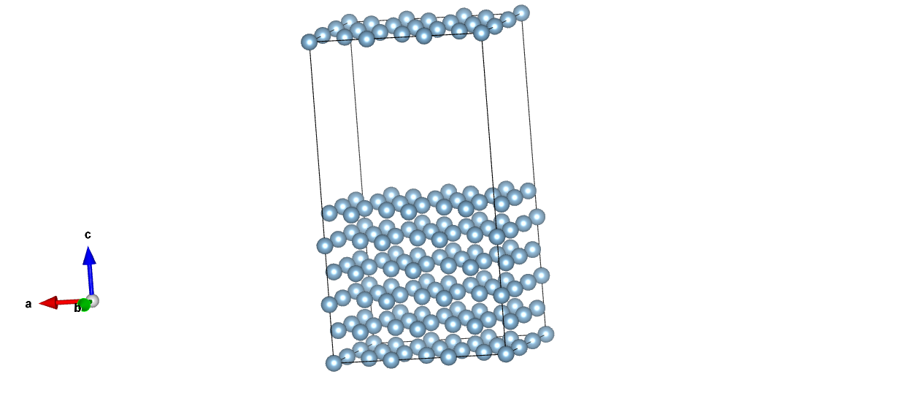

New structure

1.0

12.1199998856 0.0000000000 0.0000000000

0.0000000000 12.1199998856 0.0000000000

0.0000000000 0.0000000000 22.1199998856

Al

108

Cartesian

0.000000000 0.000000000 0.000000000

0.000000000 2.020000041 2.020000041

2.020000041 0.000000000 2.020000041

2.020000041 2.020000041 0.000000000

0.000000000 0.000000000 4.040000082

0.000000000 0.000000000 8.080000165

4.040000082 0.000000000 0.000000000

8.080000165 0.000000000 0.000000000

0.000000000 4.040000082 0.000000000

0.000000000 8.080000165 0.000000000

0.000000000 2.020000041 6.059999943

0.000000000 2.020000041 10.099999664

4.040000082 2.020000041 2.020000041

8.080000165 2.020000041 2.020000041

0.000000000 6.059999943 2.020000041

0.000000000 10.099999664 2.020000041

2.020000041 0.000000000 6.059999943

2.020000041 0.000000000 10.099999664

6.059999943 0.000000000 2.020000041

10.099999664 0.000000000 2.020000041

2.020000041 4.040000082 2.020000041

2.020000041 8.080000165 2.020000041

2.020000041 2.020000041 4.040000082

2.020000041 2.020000041 8.080000165

6.059999943 2.020000041 0.000000000

10.099999664 2.020000041 0.000000000

2.020000041 6.059999943 0.000000000

2.020000041 10.099999664 0.000000000

0.000000000 4.040000082 4.040000082

0.000000000 8.080000165 8.080000165

0.000000000 8.080000165 4.040000082

0.000000000 4.040000082 8.080000165

4.040000082 0.000000000 4.040000082

8.080000165 0.000000000 8.080000165

4.040000082 0.000000000 8.080000165

8.080000165 0.000000000 4.040000082

4.040000082 4.040000082 0.000000000

8.080000165 8.080000165 0.000000000

8.080000165 4.040000082 0.000000000

4.040000082 8.080000165 0.000000000

0.000000000 6.059999943 6.059999943

0.000000000 10.099999664 10.099999664

0.000000000 10.099999664 6.059999943

0.000000000 6.059999943 10.099999664

4.040000082 2.020000041 6.059999943

8.080000165 2.020000041 10.099999664

4.040000082 2.020000041 10.099999664

8.080000165 2.020000041 6.059999943

4.040000082 6.059999943 2.020000041

8.080000165 10.099999664 2.020000041

8.080000165 6.059999943 2.020000041

4.040000082 10.099999664 2.020000041

2.020000041 4.040000082 6.059999943

2.020000041 8.080000165 10.099999664

2.020000041 8.080000165 6.059999943

2.020000041 4.040000082 10.099999664

6.059999943 0.000000000 6.059999943

10.099999664 0.000000000 10.099999664

6.059999943 0.000000000 10.099999664

10.099999664 0.000000000 6.059999943

6.059999943 4.040000082 2.020000041

10.099999664 8.080000165 2.020000041

10.099999664 4.040000082 2.020000041

6.059999943 8.080000165 2.020000041

2.020000041 6.059999943 4.040000082

2.020000041 10.099999664 8.080000165

2.020000041 10.099999664 4.040000082

2.020000041 6.059999943 8.080000165

6.059999943 2.020000041 4.040000082

10.099999664 2.020000041 8.080000165

6.059999943 2.020000041 8.080000165

10.099999664 2.020000041 4.040000082

6.059999943 6.059999943 0.000000000

10.099999664 10.099999664 0.000000000

10.099999664 6.059999943 0.000000000

6.059999943 10.099999664 0.000000000

4.040000082 4.040000082 4.040000082

8.080000165 8.080000165 8.080000165

8.080000165 8.080000165 4.040000082

4.040000082 4.040000082 8.080000165

8.080000165 4.040000082 8.080000165

4.040000082 8.080000165 4.040000082

4.040000082 8.080000165 8.080000165

8.080000165 4.040000082 4.040000082

4.040000082 6.059999943 6.059999943

8.080000165 10.099999664 10.099999664

8.080000165 10.099999664 6.059999943

4.040000082 6.059999943 10.099999664

8.080000165 6.059999943 10.099999664

4.040000082 10.099999664 6.059999943

4.040000082 10.099999664 10.099999664

8.080000165 6.059999943 6.059999943

6.059999943 4.040000082 6.059999943

10.099999664 8.080000165 10.099999664

10.099999664 8.080000165 6.059999943

6.059999943 4.040000082 10.099999664

10.099999664 4.040000082 10.099999664

6.059999943 8.080000165 6.059999943

6.059999943 8.080000165 10.099999664

10.099999664 4.040000082 6.059999943

6.059999943 6.059999943 4.040000082

10.099999664 10.099999664 8.080000165

10.099999664 10.099999664 4.040000082

6.059999943 6.059999943 8.080000165

10.099999664 6.059999943 8.080000165

6.059999943 10.099999664 4.040000082

6.059999943 10.099999664 8.080000165

10.099999664 6.059999943 4.040000082

Al – (110)

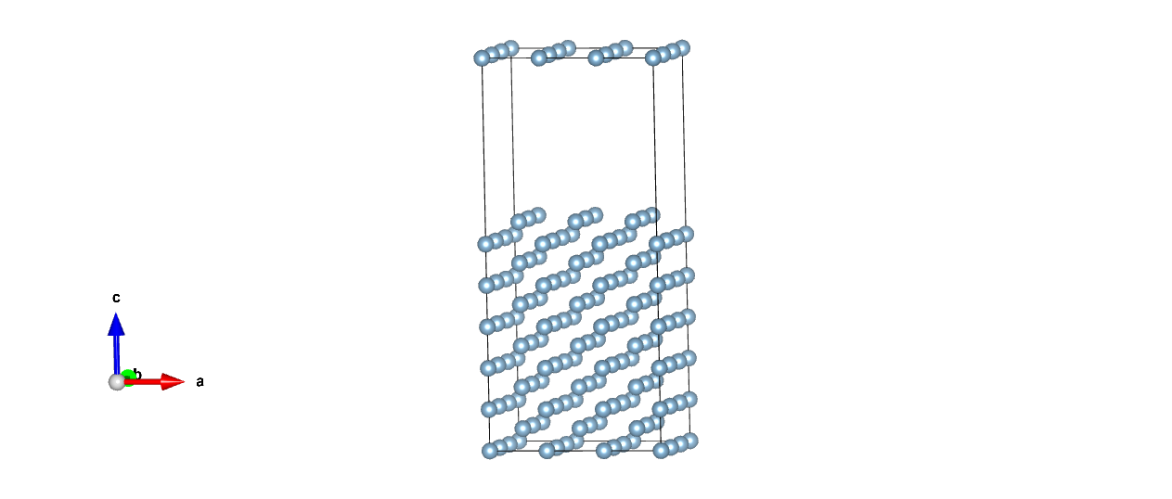

New structure

1.0

12.1199998856 0.0000000000 0.0000000000

0.0000000000 8.5701341629 0.0000000000

0.0000000000 0.0000000000 27.1402683258

Al

108

Cartesian

0.000000000 0.000000000 0.000000000

0.000000000 0.000000000 2.856711473

0.000000000 0.000000000 5.713422946

0.000000000 0.000000000 8.570134163

0.000000000 0.000000000 11.426845891

0.000000000 0.000000000 14.283556598

0.000000000 2.856711473 0.000000000

0.000000000 2.856711473 2.856711473

0.000000000 2.856711473 5.713422946

0.000000000 2.856711473 8.570134163

0.000000000 2.856711473 11.426845891

0.000000000 2.856711473 14.283556598

0.000000000 5.713422946 0.000000000

0.000000000 5.713422946 2.856711473

0.000000000 5.713422946 5.713422946

0.000000000 5.713422946 8.570134163

0.000000000 5.713422946 11.426845891

0.000000000 5.713422946 14.283556598

4.040000082 0.000000000 0.000000000

4.040000082 0.000000000 2.856711473

4.040000082 0.000000000 5.713422946

4.040000082 0.000000000 8.570134163

4.040000082 0.000000000 11.426845891

4.040000082 0.000000000 14.283556598

4.040000082 2.856711473 0.000000000

4.040000082 2.856711473 2.856711473

4.040000082 2.856711473 5.713422946

4.040000082 2.856711473 8.570134163

4.040000082 2.856711473 11.426845891

4.040000082 2.856711473 14.283556598

4.040000082 5.713422946 0.000000000

4.040000082 5.713422946 2.856711473

4.040000082 5.713422946 5.713422946

4.040000082 5.713422946 8.570134163

4.040000082 5.713422946 11.426845891

4.040000082 5.713422946 14.283556598

8.080000165 0.000000000 0.000000000

8.080000165 0.000000000 2.856711473

8.080000165 0.000000000 5.713422946

8.080000165 0.000000000 8.570134163

8.080000165 0.000000000 11.426845891

8.080000165 0.000000000 14.283556598

8.080000165 2.856711473 0.000000000

8.080000165 2.856711473 2.856711473

8.080000165 2.856711473 5.713422946

8.080000165 2.856711473 8.570134163

8.080000165 2.856711473 11.426845891

8.080000165 2.856711473 14.283556598

8.080000165 5.713422946 0.000000000

8.080000165 5.713422946 2.856711473

8.080000165 5.713422946 5.713422946

8.080000165 5.713422946 8.570134163

8.080000165 5.713422946 11.426845891

8.080000165 5.713422946 14.283556598

2.020000041 1.428355736 1.428355736

2.020000041 1.428355736 4.285067081

2.020000041 1.428355736 7.141778299

2.020000041 1.428355736 9.998489516

2.020000041 1.428355736 12.855201244

2.020000041 1.428355736 15.711912973

2.020000041 4.285067081 1.428355736

2.020000041 4.285067081 4.285067081

2.020000041 4.285067081 7.141778299

2.020000041 4.285067081 9.998489516

2.020000041 4.285067081 12.855201244

2.020000041 4.285067081 15.711912973

2.020000041 7.141778299 1.428355736

2.020000041 7.141778299 4.285067081

2.020000041 7.141778299 7.141778299

2.020000041 7.141778299 9.998489516

2.020000041 7.141778299 12.855201244

2.020000041 7.141778299 15.711912973

6.059999943 1.428355736 1.428355736

6.059999943 1.428355736 4.285067081

6.059999943 1.428355736 7.141778299

6.059999943 1.428355736 9.998489516

6.059999943 1.428355736 12.855201244

6.059999943 1.428355736 15.711912973

6.059999943 4.285067081 1.428355736

6.059999943 4.285067081 4.285067081

6.059999943 4.285067081 7.141778299

6.059999943 4.285067081 9.998489516

6.059999943 4.285067081 12.855201244

6.059999943 4.285067081 15.711912973

6.059999943 7.141778299 1.428355736

6.059999943 7.141778299 4.285067081

6.059999943 7.141778299 7.141778299

6.059999943 7.141778299 9.998489516

6.059999943 7.141778299 12.855201244

6.059999943 7.141778299 15.711912973

10.099999664 1.428355736 1.428355736

10.099999664 1.428355736 4.285067081

10.099999664 1.428355736 7.141778299

10.099999664 1.428355736 9.998489516

10.099999664 1.428355736 12.855201244

10.099999664 1.428355736 15.711912973

10.099999664 4.285067081 1.428355736

10.099999664 4.285067081 4.285067081

10.099999664 4.285067081 7.141778299

10.099999664 4.285067081 9.998489516

10.099999664 4.285067081 12.855201244

10.099999664 4.285067081 15.711912973

10.099999664 7.141778299 1.428355736

10.099999664 7.141778299 4.285067081

10.099999664 7.141778299 7.141778299

10.099999664 7.141778299 9.998489516

10.099999664 7.141778299 12.855201244

10.099999664 7.141778299 15.711912973

Al – (111)

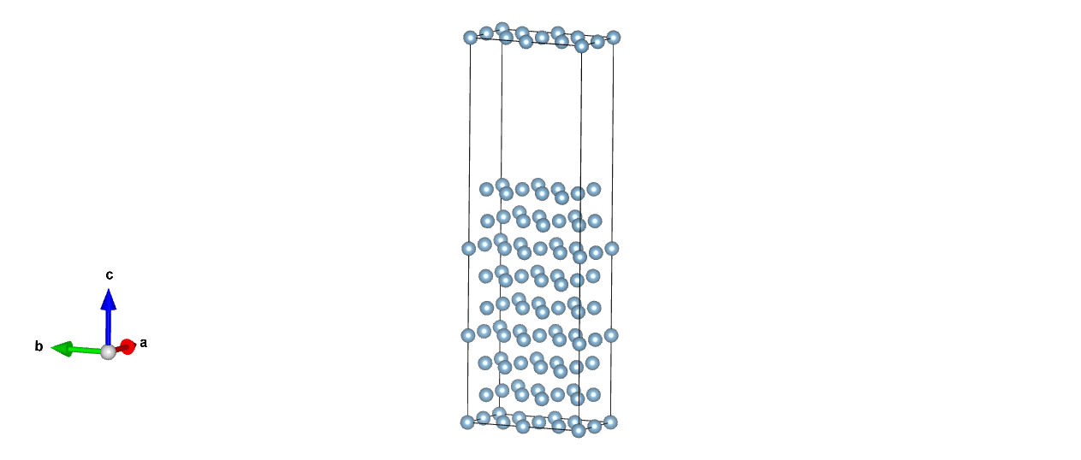

New structure

1.0

5.7134227753 0.0000000000 0.0000000000

0.0000000000 9.8959388733 0.0000000000

0.0000000000 0.0000000000 30.9924545288

Al

72

Cartesian

0.000000000 0.000000000 0.000000000

0.000000000 0.000000000 6.997485051

0.000000000 0.000000000 13.994970103

0.000000000 4.947969437 0.000000000

0.000000000 4.947969437 6.997485051

0.000000000 4.947969437 13.994970103

2.856711388 0.000000000 0.000000000

2.856711388 0.000000000 6.997485051

2.856711388 0.000000000 13.994970103

2.856711388 4.947969437 0.000000000

2.856711388 4.947969437 6.997485051

2.856711388 4.947969437 13.994970103

1.428355694 0.824661597 2.332494965

1.428355694 0.824661597 9.329979860

1.428355694 0.824661597 16.327464912

1.428355694 5.772630813 2.332494965

1.428355694 5.772630813 9.329979860

1.428355694 5.772630813 16.327464912

4.285067081 0.824661597 2.332494965

4.285067081 0.824661597 9.329979860

4.285067081 0.824661597 16.327464912

4.285067081 5.772630813 2.332494965

4.285067081 5.772630813 9.329979860

4.285067081 5.772630813 16.327464912

0.000000000 3.298646389 2.332494965

0.000000000 3.298646389 9.329979860

0.000000000 3.298646389 16.327464912

0.000000000 8.246616121 2.332494965

0.000000000 8.246616121 9.329979860

0.000000000 8.246616121 16.327464912

2.856711388 3.298646389 2.332494965

2.856711388 3.298646389 9.329979860

2.856711388 3.298646389 16.327464912

2.856711388 8.246616121 2.332494965

2.856711388 8.246616121 9.329979860

2.856711388 8.246616121 16.327464912

0.000000000 1.649323195 4.664989930

0.000000000 1.649323195 11.662475294

0.000000000 1.649323195 18.659959720

0.000000000 6.597292779 4.664989930

0.000000000 6.597292779 11.662475294

0.000000000 6.597292779 18.659959720

2.856711388 1.649323195 4.664989930

2.856711388 1.649323195 11.662475294

2.856711388 1.649323195 18.659959720

2.856711388 6.597292779 4.664989930

2.856711388 6.597292779 11.662475294

2.856711388 6.597292779 18.659959720

1.428355694 4.123307766 4.664989930

1.428355694 4.123307766 11.662475294

1.428355694 4.123307766 18.659959720

1.428355694 9.071276907 4.664989930

1.428355694 9.071276907 11.662475294

1.428355694 9.071276907 18.659959720

4.285067081 4.123307766 4.664989930

4.285067081 4.123307766 11.662475294

4.285067081 4.123307766 18.659959720

4.285067081 9.071276907 4.664989930

4.285067081 9.071276907 11.662475294

4.285067081 9.071276907 18.659959720

1.428355694 2.473984718 0.000000000

1.428355694 2.473984718 6.997485051

1.428355694 2.473984718 13.994970103

1.428355694 7.421954155 0.000000000

1.428355694 7.421954155 6.997485051

1.428355694 7.421954155 13.994970103

4.285067081 2.473984718 0.000000000

4.285067081 2.473984718 6.997485051

4.285067081 2.473984718 13.994970103

4.285067081 7.421954155 0.000000000

4.285067081 7.421954155 6.997485051

4.285067081 7.421954155 13.994970103

2.Nacl - {111}

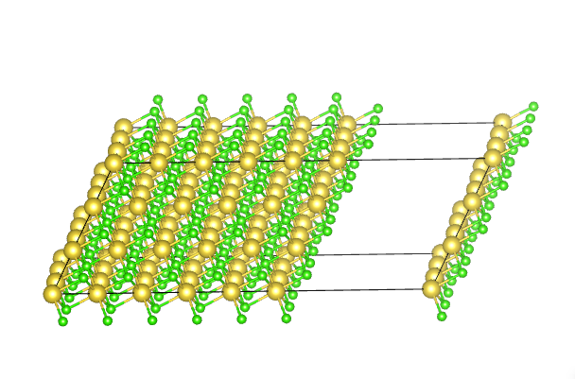

New structure

1.0

34.1830520630 0.0000000000 0.0000000000

6.0457623186 10.4715691163 0.0000000000

-6.0457630157 -3.4905231729 9.8726895680

Na Cl

54 54

Cartesian

0.000000000 0.000000000 0.000000000

-2.015254399 -1.163507759 3.290896621

-4.030508797 -2.327015518 6.581793242

2.015254166 3.490523143 0.000000000

-0.000000232 2.327015384 3.290896621

-2.015254631 1.163507625 6.581793242

4.030508332 6.981046286 0.000000000

2.015253934 5.817538527 3.290896621

-0.000000465 4.654030768 6.581793242

4.030508797 0.000000000 0.000000000

2.015254399 -1.163507759 3.290896621

0.000000000 -2.327015518 6.581793242

6.045762964 3.490523143 0.000000000

4.030508565 2.327015384 3.290896621

2.015254166 1.163507625 6.581793242

8.061017130 6.981046286 0.000000000

6.045762731 5.817538527 3.290896621

4.030508332 4.654030768 6.581793242

8.061017595 0.000000000 0.000000000

6.045763196 -1.163507759 3.290896621

4.030508797 -2.327015518 6.581793242

10.076271761 3.490523143 0.000000000

8.061017362 2.327015384 3.290896621

6.045762964 1.163507625 6.581793242

12.091525927 6.981046286 0.000000000

10.076271528 5.817538527 3.290896621

8.061017130 4.654030768 6.581793242

12.091526031 0.000000000 0.000000000

10.076271633 -1.163507759 3.290896621

8.061017234 -2.327015518 6.581793242

14.106780198 3.490523143 0.000000000

12.091525799 2.327015384 3.290896621

10.076271400 1.163507625 6.581793242

16.122034364 6.981046286 0.000000000

14.106779965 5.817538527 3.290896621

12.091525567 4.654030768 6.581793242

16.122035189 0.000000000 0.000000000

14.106780790 -1.163507759 3.290896621

12.091526392 -2.327015518 6.581793242

18.137289355 3.490523143 0.000000000

16.122034957 2.327015384 3.290896621

14.106780558 1.163507625 6.581793242

20.152543522 6.981046286 0.000000000

18.137289123 5.817538527 3.290896621

16.122034724 4.654030768 6.581793242

20.152542905 0.000000000 0.000000000

18.137288507 -1.163507759 3.290896621

16.122034108 -2.327015518 6.581793242

22.167797072 3.490523143 0.000000000

20.152542673 2.327015384 3.290896621

18.137288274 1.163507625 6.581793242

24.183051238 6.981046286 0.000000000

22.167796839 5.817538527 3.290896621

20.152542441 4.654030768 6.581793242

2.015254282 1.163507692 1.645448310

-0.000000026 -0.000000015 4.936344784

-2.015254245 -1.163507670 8.227241111

4.030508359 4.654030679 1.645448310

2.015254050 3.490522972 4.936344784

-0.000000168 2.327015317 8.227241111

6.045762345 8.144553509 1.645448310

4.030508036 6.981045802 4.936344784

2.015253818 5.817538147 8.227241111

6.045762900 1.163507692 1.645448310

4.030508591 -0.000000015 4.936344784

2.015254373 -1.163507670 8.227241111

8.061016976 4.654030679 1.645448310

6.045762667 3.490522972 4.936344784

4.030508449 2.327015317 8.227241111

10.076270962 8.144553509 1.645448310

8.061016653 6.981045802 4.936344784

6.045762435 5.817538147 8.227241111

10.076271336 1.163507692 1.645448310

8.061017028 -0.000000015 4.936344784

6.045762809 -1.163507670 8.227241111

12.091525413 4.654030679 1.645448310

10.076271104 3.490522972 4.936344784

8.061016886 2.327015317 8.227241111

14.106779399 8.144553509 1.645448310

12.091525090 6.981045802 4.936344784

10.076270872 5.817538147 8.227241111

14.106779773 1.163507692 1.645448310

12.091525465 -0.000000015 4.936344784

10.076271246 -1.163507670 8.227241111

16.122033850 4.654030679 1.645448310

14.106779541 3.490522972 4.936344784

12.091525323 2.327015317 8.227241111

18.137287836 8.144553509 1.645448310

16.122033527 6.981045802 4.936344784

14.106779309 5.817538147 8.227241111

18.137288931 1.163507692 1.645448310

16.122034622 -0.000000015 4.936344784

14.106780404 -1.163507670 8.227241111

20.152543007 4.654030679 1.645448310

18.137288699 3.490522972 4.936344784

16.122034480 2.327015317 8.227241111

22.167796993 8.144553509 1.645448310

20.152542685 6.981045802 4.936344784

18.137288466 5.817538147 8.227241111

22.167798089 1.163507692 1.645448310

20.152543780 -0.000000015 4.936344784

18.137289562 -1.163507670 8.227241111

24.183052165 4.654030679 1.645448310

22.167797856 3.490522972 4.936344784

20.152543638 2.327015317 8.227241111

26.198306151 8.144553509 1.645448310

24.183051842 6.981045802 4.936344784

22.167797624 5.817538147 8.227241111

**Question 5**

The energy values are

|  |  |
| --- | --- |
| Distance in Angstrom | Energy in eV |
| 0.94 | -1.10404755 |
| 1.04 | -14.79347335 |
| 1.14 | -14.7934226 |
| 1.24 | -14.79371015 |
| 1.24 | -14.79367252 |

The Morse potential fits better because the atom are also vibrating in addition to the potential energy it has. Only electrostatic energy will have quadratic equation as a better fit.